**Twitter API Real Time Application**

1. In order to use Twitter’s API, we have to create a developer account on the [https://apps.twitter.com/ Twitter apps site.](https://apps.twitter.com/)

2. Log in or make a Twitter account at <https://apps.twitter.com/>

3. Click on **“Apply for a developer account”** button

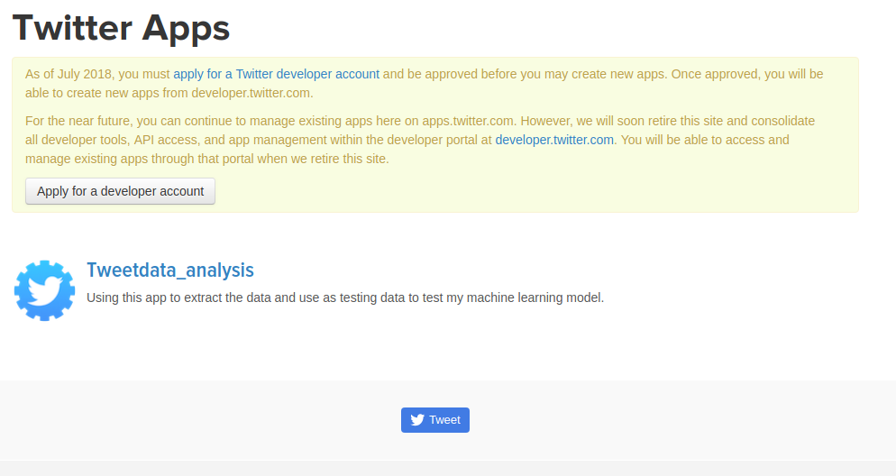

4. Once you click on the button, You should be able to see the screen as below :

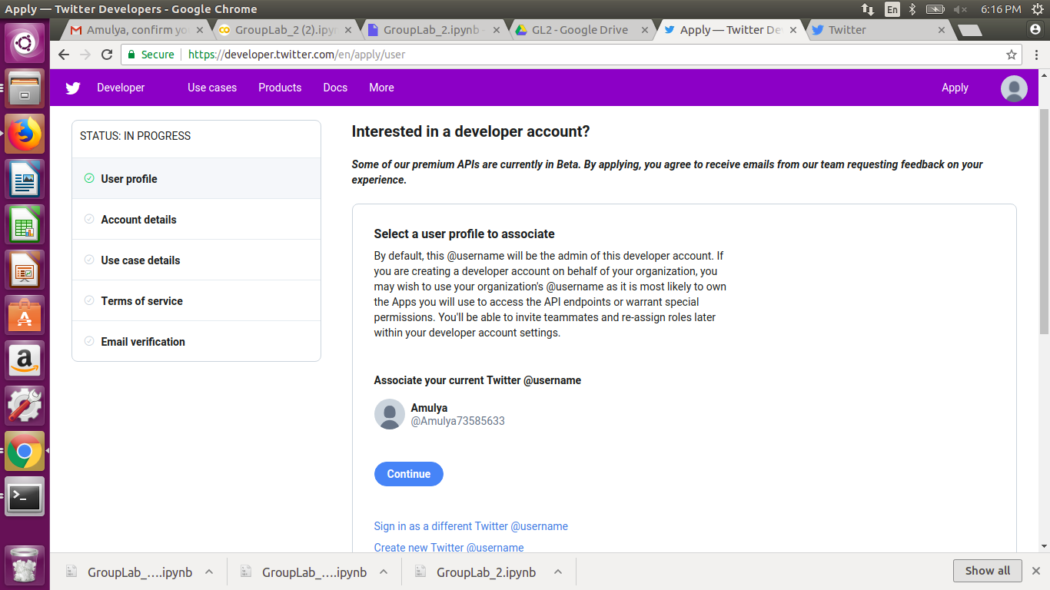

5. Click on **“continue”** button. You will be the screen as below :

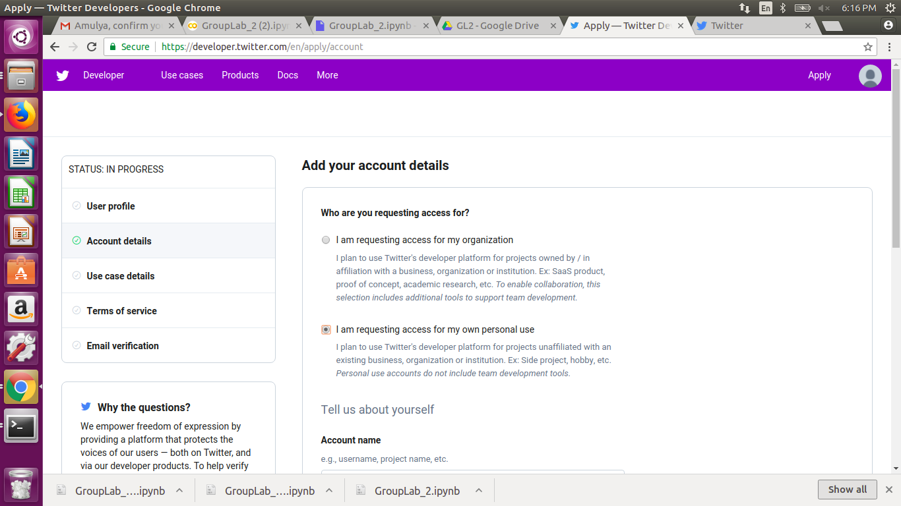

6. Then select the username and country of operation as show below in the image:

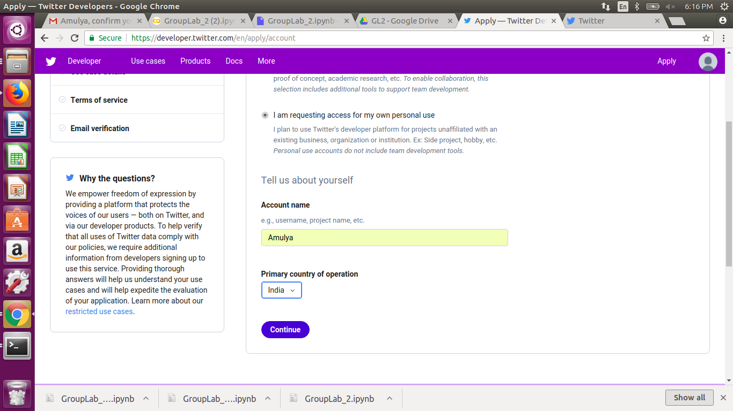

7. Once you fill the details then click on **“continue”** button. You will be able to see the screen as below. Then select the use case as Student project/ Learning to code.

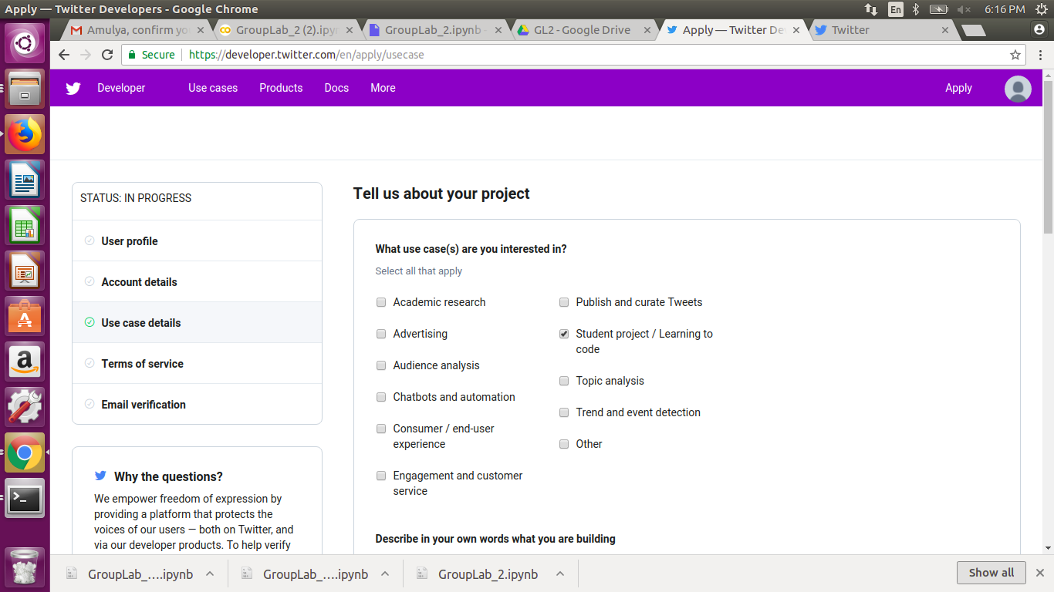

8. Then we have to describe about the application we are building in at least 300 characters. In this group lab we are trying to build a real time twitter sentiment analysis application on a particular query.

***Sample :***

*1. I would like to perform a text analysis like sentimental analysis using the twitter data based on a single query.*

*2. Yes I would like to analyze the model using various machine learning algorithms like SVM, KNN*

*3. No, My app doesn't perform retweeting or tweeting just I will be using the app to download the data.*

*4. The data downloaded from the twitter will be presented in an excel format to the user.*

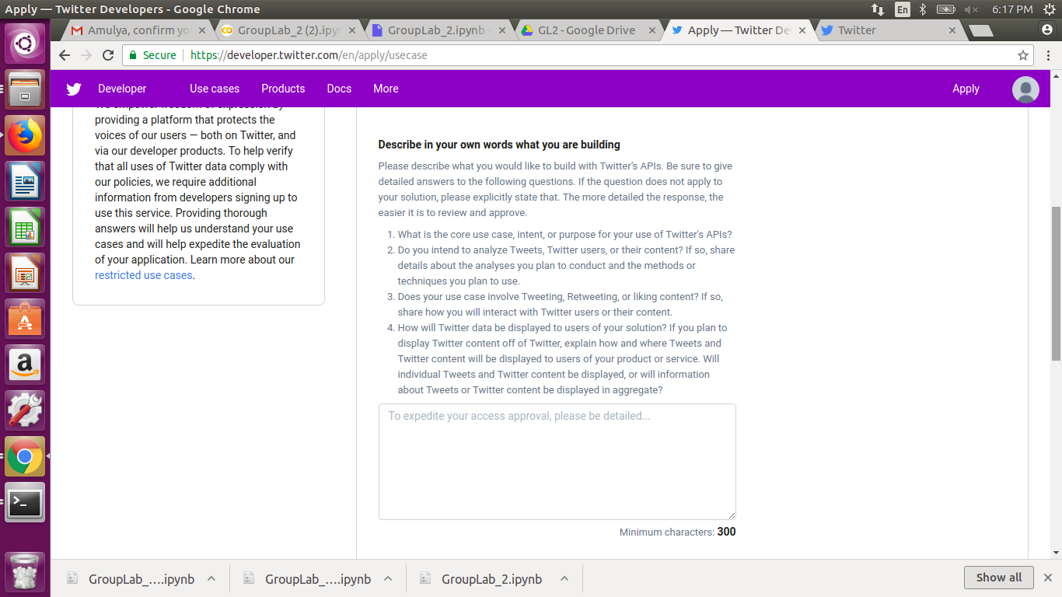

9. In the same page answer the next question as NO. as shown in the below screenshot:

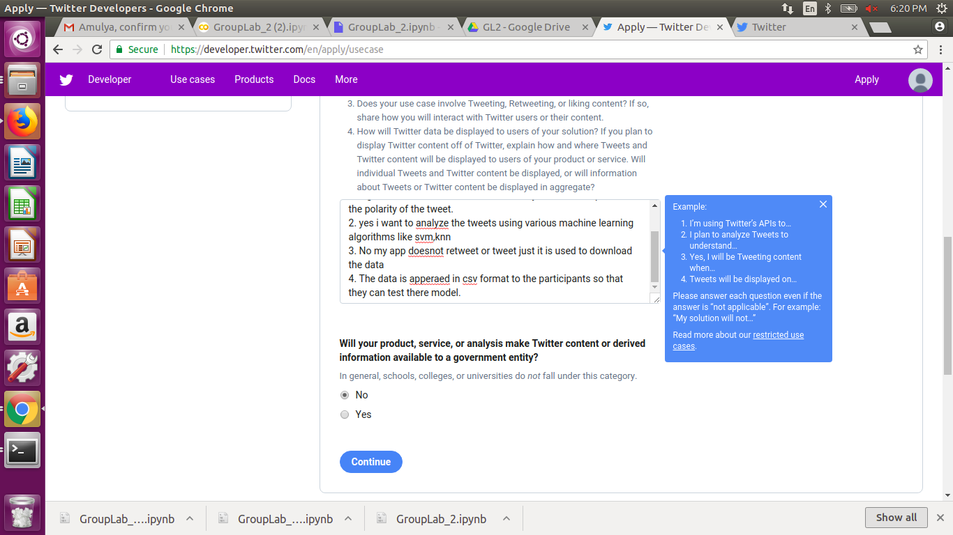

Then click on **“continue”** button. You should be able to see the screen as shown in the below screenshot.

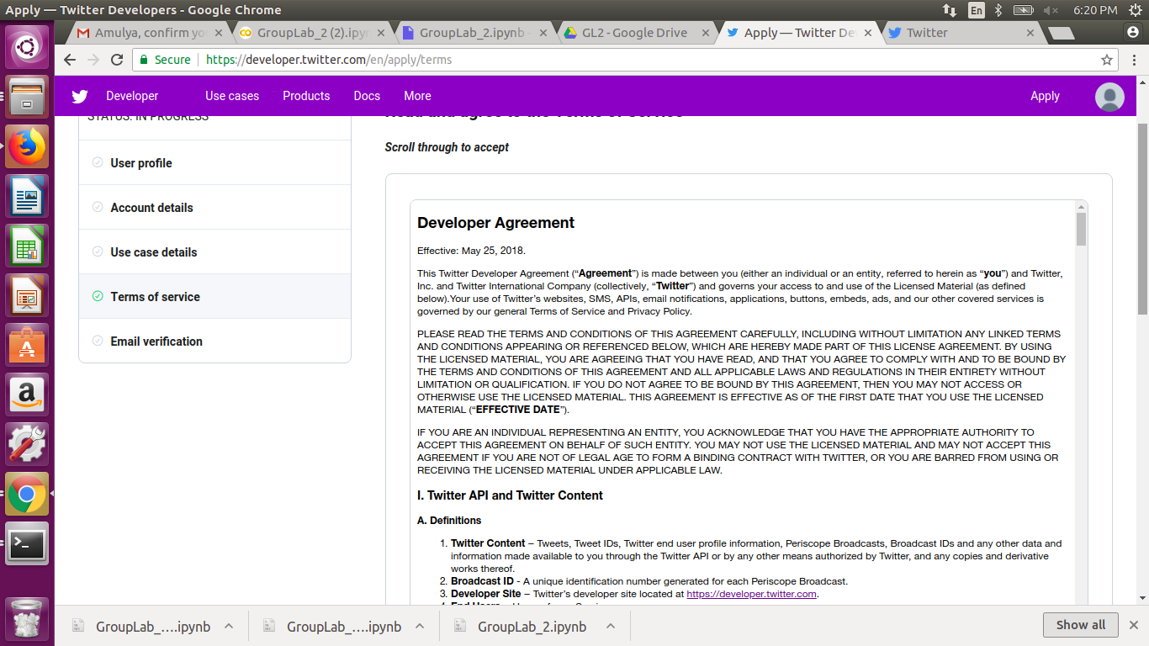

10. Once you agree to the terms and conditions then you should be able to see the screen as shown in the below :

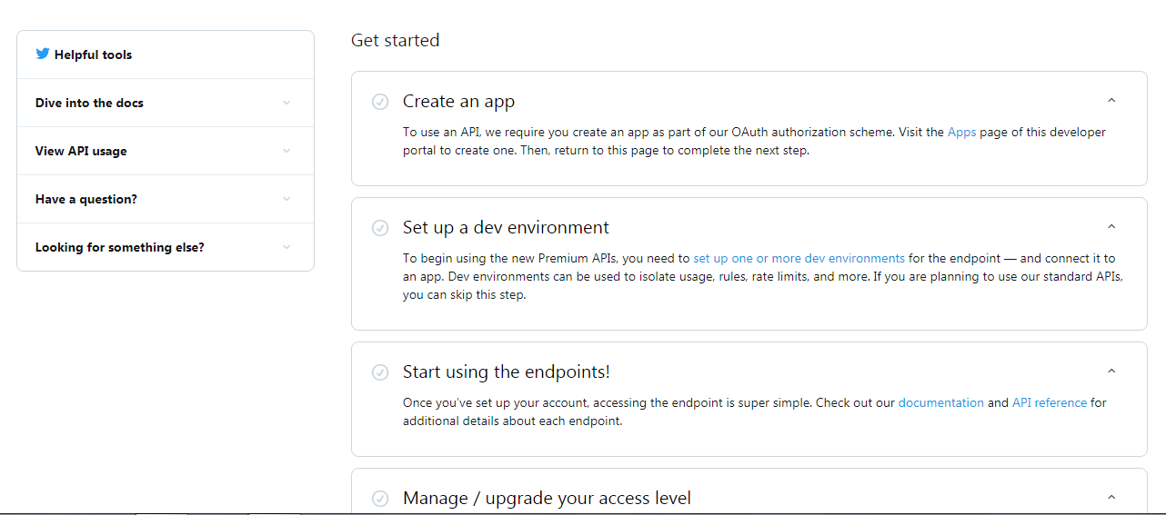

11. Select **“Create an app”** then you should be able to see the screen as shown in the below screenshot

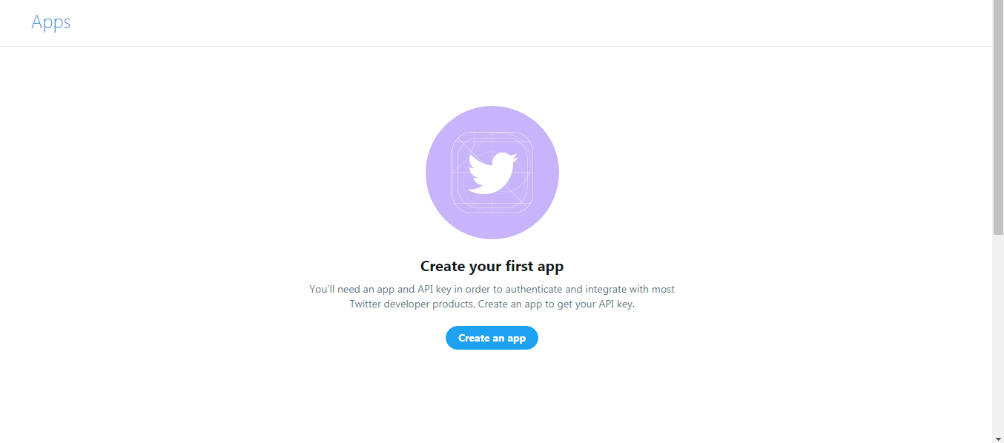

12. Click **“Create an app”** then you should be able to see the screen as shown in the below screenshot:

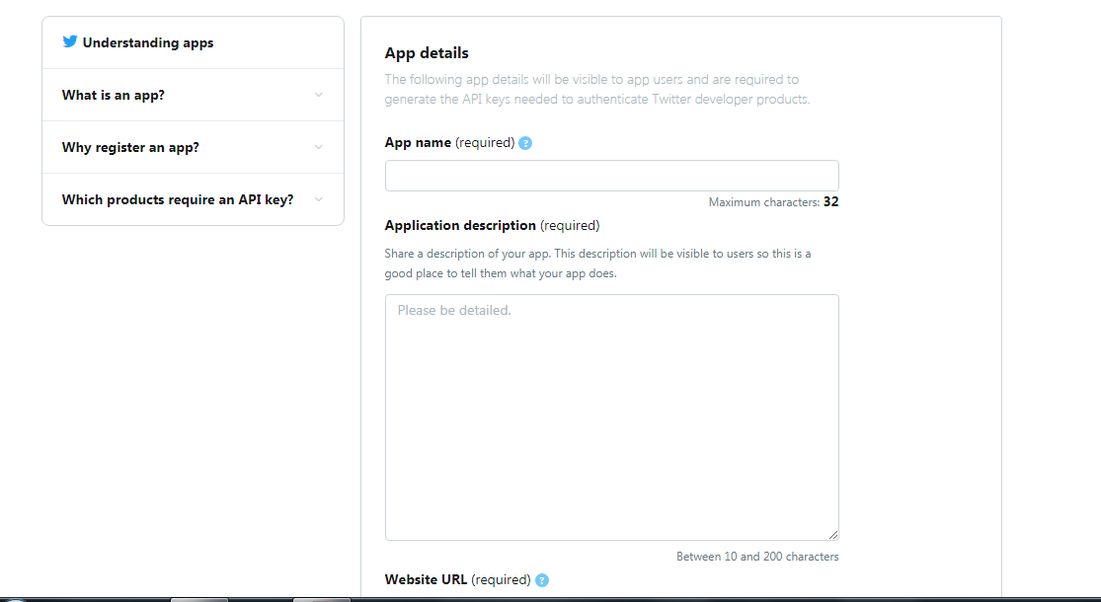

13. Fill the details regarding the APP description, urls e.t.c. Then click on **“Create”** you should be able to see the screen as below :

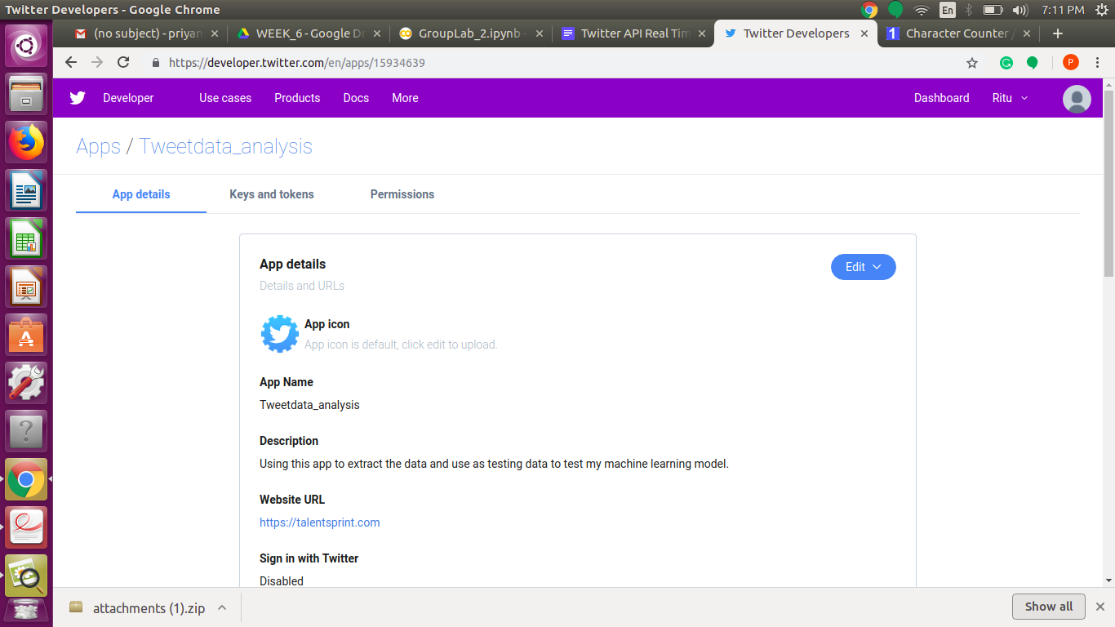

14. To access the Keys and token migrate into **“Keys and tokens“** tab as shown in the below screenshot :

